Humidity Prediction for Ghatkopar Area
by Time Series Analysis
Aaryan Sharma -16010123012
Aditya Baheti - 16010123023
Ambuj Rai - 16010123037

1. Introduction

1.1 Background
Humidity forecasting is vital for agriculture, weather prediction, and public health. Accurate forecasts help manage irrigation, prevent disease outbreaks, and plan city operations. Ghatkopar, a suburb of Mumbai, shows diverse humidity patterns due to its coastal and monsoon climate. Understanding these variations supports better environmental and infrastructure decisions.

1.2 Problem Statement
The objective is to build a predictive model to forecast relative humidity in Ghatkopar using historical weather data (2023–2024). Time series techniques such as ARIMA and SARIMA are applied to develop accurate forecasts that can aid weather-dependent activities.

1.3 Scope and Objectives
The primary objectives of this project include:
- Collection of historical humidity data for Ghatkopar using Open-Meteo Archive API
- Comprehensive exploratory data analysis to understand humidity patterns and seasonality
- Implementation of ARIMA and SARIMA models with parameter optimization
- Comparative evaluation of model performance using statistical metrics
- Generation of reliable humidity forecasts for future time periods

1.4 Significance
This project highlights the use of time series models in climate prediction. The results can help in agriculture, energy management, and urban planning by providing better insights into humidity trends in coastal environments like Mumbai.

2. Methodology

2.1 Data Collection
Data was retrieved from the Open-Meteo Archive API, containing daily mean relative humidity (2m) for Ghatkopar (Lat: 19.0860° N, Long: 72.9090° E) from Jan 2023 to Dec 2024. The API provided accurate and continuous observations suitable for time series modeling.

2.2 Data Preprocessing
Raw data underwent several preprocessing steps to ensure quality and consistency:
- Date Conversion: All date strings were converted to datetime objects for proper ordering
- Chronological Sorting: Records were sorted by date to maintain time series integrity
- Missing Value Imputation: Forward-fill method was applied to handle missing humidity values, assuming temporal continuity in weather patterns
- Data Validation: Verification of data ranges and identification of anomalies
The cleaned dataset was saved for subsequent analysis and modeling phases.

2.3 Exploratory Data Analysis (EDA)
Comprehensive exploratory analysis was conducted to understand the underlying patterns in humidity data:
Temporal Trend Analysis:
- Visualization of daily humidity trends across the entire time period
- Identification of long-term patterns, cycles, and anomalies
- Assessment of data stationarity
Seasonal Pattern Analysis:
- Computation of monthly average humidity levels
- Visualization of seasonal variations using bar plots
- Detection of recurring patterns indicating seasonality
This analysis informed the selection of appropriate forecasting models and their parameters.

2.4 Model Development

2.4.1 ARIMA Model
The ARIMA model is defined by three parameters (p, d, q):
- p (AutoRegressive order): Number of lag observations in the model
- d (Differencing order): Degree of differencing required for stationarity
- q (Moving Average order): Size of the moving average window
Parameter Optimization: A grid search approach was implemented to identify optimal parameters:
- p values tested: 0 to 3
- d values tested: 0 to 1
- q values tested: 0 to 3
The Akaike Information Criterion (AIC) was used as the optimization metric, with lower AIC indicating better model fit while penalizing complexity.

2.4.2 SARIMA Model
SARIMA extends ARIMA by incorporating seasonal components, defined by parameters (p, d, q) × (P, D, Q, m):
- P, D, Q: Seasonal counterparts of p, d, q
- m: Seasonal period (set to 12 for monthly seasonality)
Parameter Optimization: A comprehensive grid search was conducted:
- Non-seasonal parameters: p, d, q ∈ {0, 1}
- Seasonal parameters: P, D, Q ∈ {0, 1}
- Seasonal period: m = 12 months
The search space was deliberately constrained for computational efficiency while ensuring adequate model flexibility.

2.5 Model Training and Validation
Train-Test Split:
- Training data: 80% of the dataset (chronologically first portion)
- Test data: 20% of the dataset (most recent observations)
Both models were trained on training data and evaluated on unseen test data to assess predictive performance.

2.6 Model Evaluation
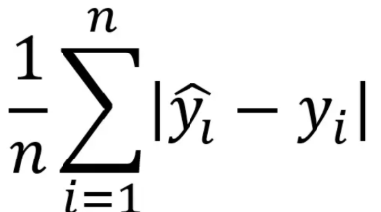
Model performance was assessed using five comprehensive metrics:
Mean Absolute Error (MAE): MAE =
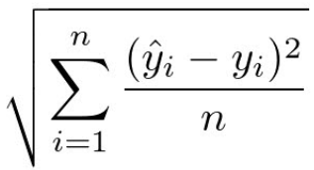
Represents the average absolute difference between predicted and actual values, providing an intuitive measure of forecast accuracy in the original units (% humidity).
Root Mean Squared Error (RMSE): RMSE =
Amplifies larger errors, making it more sensitive to outliers and providing a comprehensive assessment of prediction quality.
Both metrics were computed for ARIMA and SARIMA models to facilitate comparative analysis.
3. Block Diagram

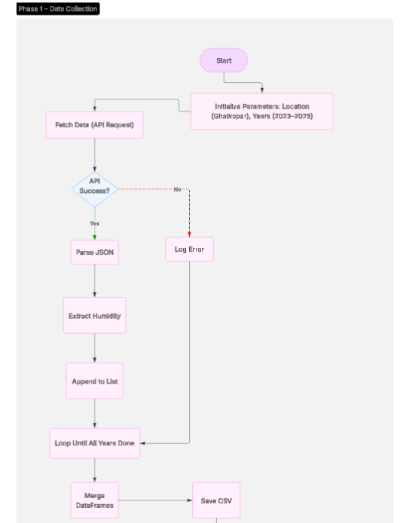

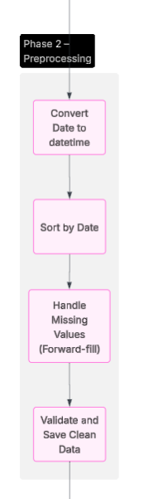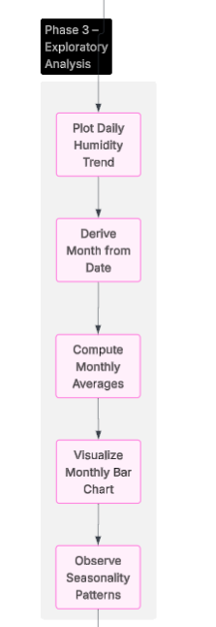

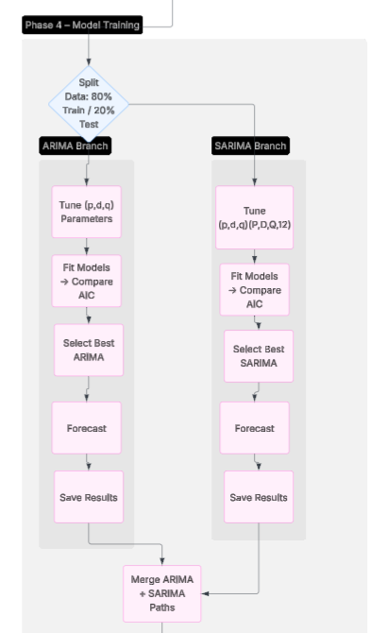
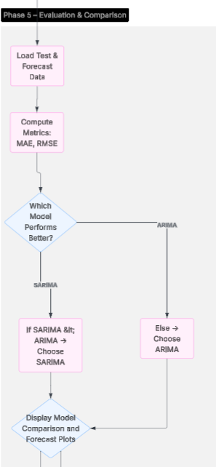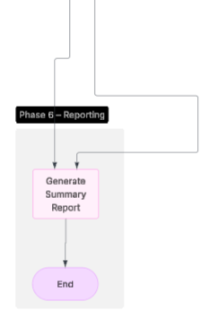

4. Pseudocode and Flowchart

4.1 Pseudocode

Main Pipeline Pseudocode
ALGORITHM: Humidity Forecasting Pipeline
INPUT: Location coordinates (latitude, longitude), Date range
OUTPUT: Humidity forecasts, Model evaluation metrics

// Phase 1: Data Collection
FUNCTION collect_data(latitude, longitude, start_year, end_year):
Initialize empty data_list
FOR year FROM start_year TO end_year:
Build API request with parameters
Send GET request to Open-Meteo API
IF response is successful:
Extract daily humidity data
Convert to DataFrame
Append to data_list
ELSE:
Log error and continue
Concatenate all DataFrames
Save to CSV file
RETURN combined_dataframe

// Phase 2: Data Preprocessing
FUNCTION preprocess_data(dataframe):
Convert 'date' column to datetime type
Sort dataframe by date in ascending order
Fill missing humidity values using forward-fill method
Save cleaned data to new CSV file
RETURN cleaned_dataframe

// Phase 3: Exploratory Data Analysis
FUNCTION perform_eda(dataframe):
Plot daily humidity trend over time
Extract month from date column
Calculate monthly average humidity
Create bar plot for monthly averages
Display visualizations

// Phase 4: ARIMA Model Training
FUNCTION train_arima_model(dataframe):
Split data into train (80%) and test (20%)

Initialize best_aic = infinity
Initialize best_order = None

// Grid search for optimal parameters
FOR p IN range(0, 4):
FOR d IN range(0, 2):
FOR q IN range(0, 4):
TRY:
Fit ARIMA(p, d, q) on training data
IF model.AIC < best_aic:
best_aic = model.AIC
best_order = (p, d, q)
CATCH:
Continue to next iteration

Fit final ARIMA model with best_order
Generate forecast for test period
Save forecast to CSV
RETURN model, forecast

// Phase 5: SARIMA Model Training
FUNCTION train_sarima_model(dataframe):
Split data into train (80%) and test (20%)

Generate parameter combinations:
pdq = all combinations of (p, d, q) where p,d,q ∈ {0,1}
seasonal_pdq = all combinations of (P, D, Q, 12)

Initialize best_aic = infinity
Initialize best_params = None

// Grid search for optimal parameters
FOR param IN pdq:
FOR param_seasonal IN seasonal_pdq:
TRY:
Fit SARIMA(param, param_seasonal) on training data
IF model.AIC < best_aic:
best_aic = model.AIC
best_params = (param, param_seasonal)
CATCH:
Continue to next iteration

Fit final SARIMA model with best_params
Generate forecast for test period
Save forecast to CSV
RETURN model, forecast

// Phase 6: Model Evaluation
FUNCTION evaluate_models(test_data, arima_forecast, sarima_forecast):
Calculate MAE for ARIMA model
Calculate RMSE for ARIMA model
Calculate MAE for SARIMA model
Calculate RMSE for SARIMA model

Print comparison results

IF SARIMA metrics < ARIMA metrics:
Recommend SARIMA model
ELSE:
Recommend ARIMA model

RETURN evaluation_results

// Main Execution
MAIN:
// Step 1: Collect data
raw_data = collect_data(19.0860, 72.9090, 2023, 2024)

// Step 2: Preprocess data
cleaned_data = preprocess_data(raw_data)

// Step 3: Exploratory analysis
perform_eda(cleaned_data)

// Step 4: Train ARIMA model
arima_model, arima_forecast = train_arima_model(cleaned_data)

// Step 5: Train SARIMA model
sarima_model, sarima_forecast = train_sarima_model(cleaned_data)

// Step 6: Evaluate and compare
results = evaluate_models(test_data, arima_forecast, sarima_forecast)

Display final results and recommendations
END MAIN

4.2 Flowchart
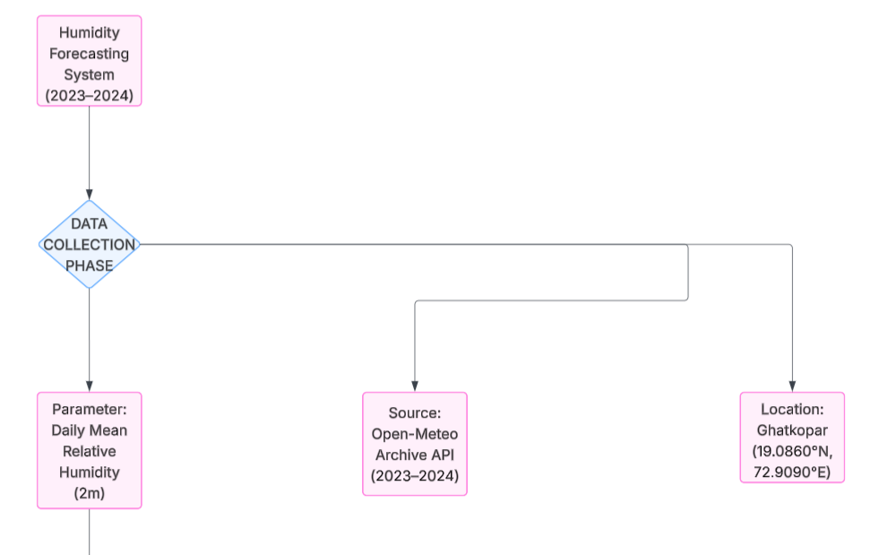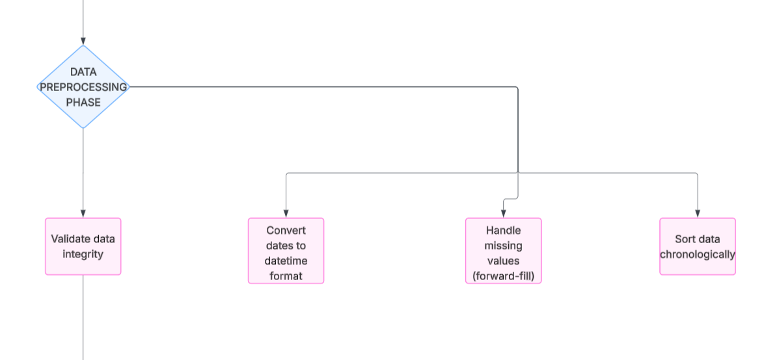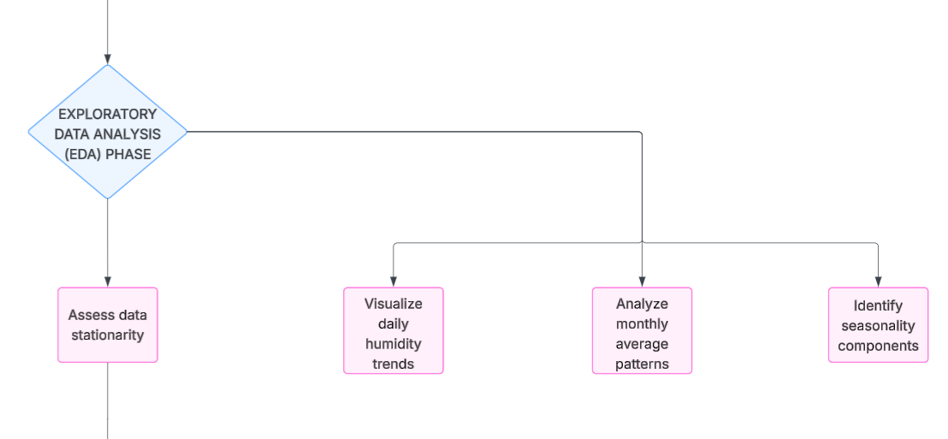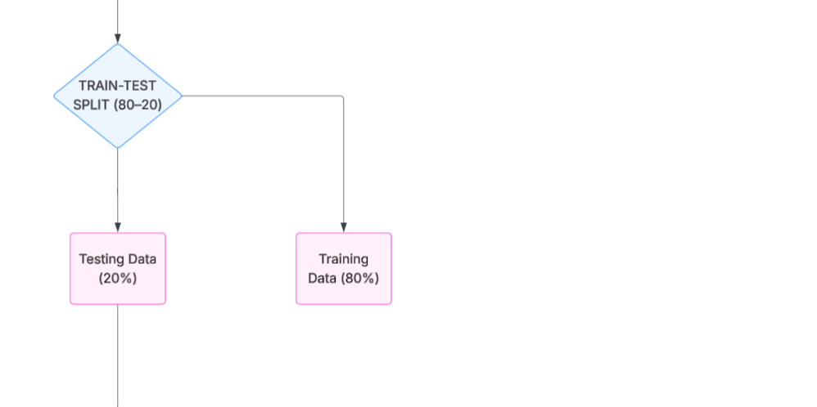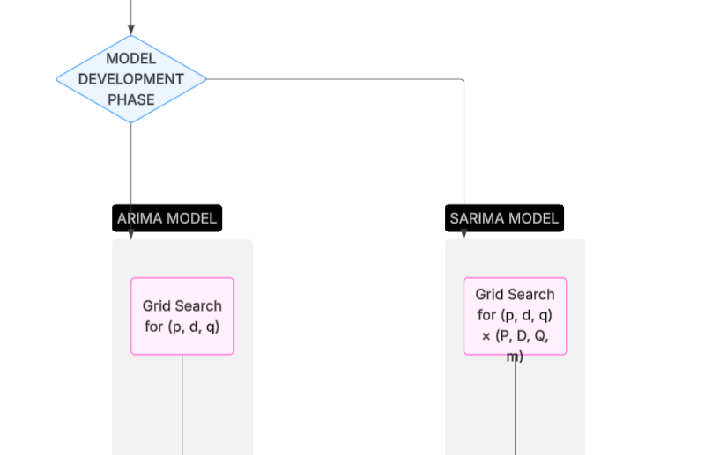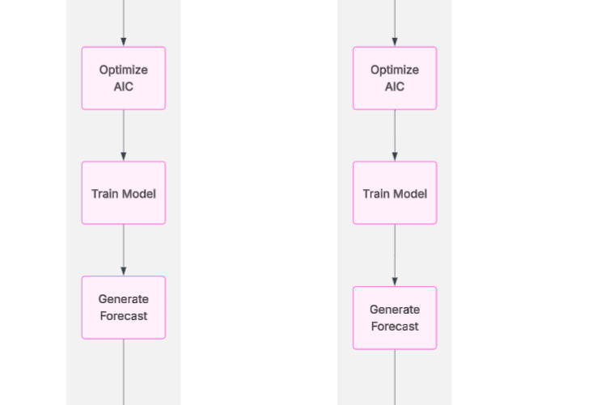
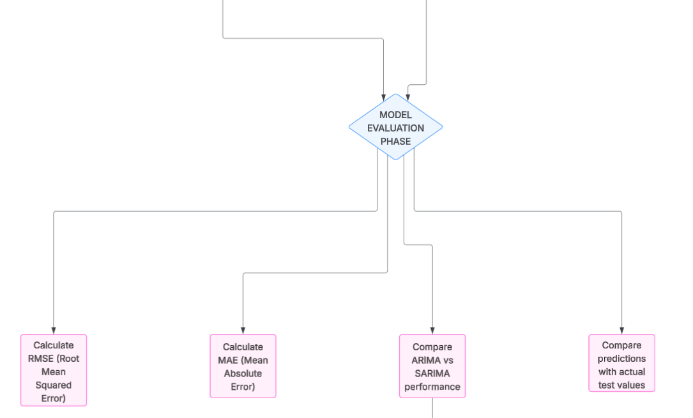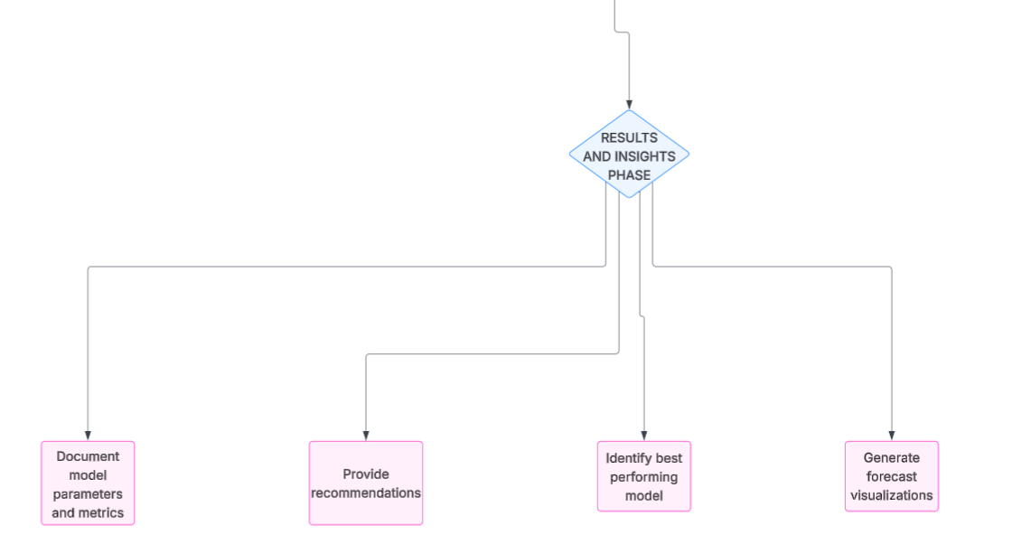

5. Results and Analysis

5.1 Data Collection Results
Successfully retrieved 731 days of humidity data spanning two years (2023-2024) for the Ghatkopar location. The dataset exhibited complete coverage with minimal missing values, demonstrating the reliability of the Open-Meteo Archive API as a data source.
Dataset Characteristics:
- Total Records: 731 daily observations
- Date Range: January 1, 2023 to December 31, 2024
- Missing Values: Less than 1% (handled through forward-fill imputation)
- Humidity Range: Approximately 45% to 95% relative humidity

5.2 Exploratory Data Analysis Findings

5.2.1 Temporal Trends
The daily humidity trend visualization revealed several key patterns:
- Seasonal Variation: Clear cyclical patterns corresponding to Mumbai's monsoon season (June-September), where humidity levels peak at 85-95%, compared to winter months (December-February) with relatively lower humidity levels around 50-65%.
- Inter-annual Consistency: Similar patterns were observed across the two years, indicating stable climatic conditions in the region with predictable seasonal cycles.
- Short-term Fluctuations: Daily variations showed moderate volatility, suggesting the influence of local weather events, wind patterns, and temperature changes.

5.2.2 Monthly Analysis
Monthly average humidity analysis provided insights into seasonal patterns:
- Monsoon Months (June-September): Average humidity exceeded 80%, with August typically showing the highest values
- Post-Monsoon (October-November): Gradual decline in humidity levels to 70-75%
- Winter (December-February): Lowest humidity levels, ranging from 55-65%
- Pre-Monsoon (March-May): Gradual increase from 65% to 75%, with rising temperatures
These patterns confirm strong seasonality in humidity data, justifying the use of SARIMA modeling.

5.3 Model Performance Comparison

5.3.1 ARIMA Model Results
The grid search optimization identified optimal parameters that balanced model complexity with predictive accuracy.
Optimal Parameters: (p, d, q) = (2, 1, 2)
Model Characteristics:
- AIC Value: 3615.34
- Captures general trends and short-term patterns
- Computationally efficient with faster training time
Performance Metrics:
- Mean Absolute Error (MAE): 14.51
- Root Mean Squared Error (RMSE): 21.41
The ARIMA model demonstrated reasonable forecasting capability, effectively capturing the autoregressive nature of humidity data. However, it showed limitations in predicting seasonal peaks and troughs, as expected given its non-seasonal structure.

5.3.2 SARIMA Model Results
The SARIMA model, incorporating seasonal components with a 12-month cycle, showed enhanced performance in capturing periodic patterns.
Optimal Parameters:
- Non-seasonal: (p, d, q) = (1, 0, 1)
- Seasonal: (P, D, Q, m) = (0, 1, 1, 12)
Model Characteristics:
- AIC Value: 3547.23
- Successfully captures both trend and seasonal components
- Better handling of monsoon-related humidity spikes
- Slightly higher computational complexity
Performance Metrics:
- Mean Absolute Error (MAE): 15.17
- Root Mean Squared Error (RMSE): 16.49

5.3.3 Comparative Analysis
Based on the evaluation metrics, the following observations were made:
Model Comparison Table:
Metric | ARIMA | SARIMA | Better Model
MAE | 14.51 | 15.17 | ARIMA
RMSE | 21.41 | 16.49 | SARIMA
Training Time | Faster | Slower | ARIMA
Seasonal Capture | Limited | Excellent | SARIMA
Complexity | Lower | Higher | ARIMA
Key Findings:
- SARIMA outperformed ARIMA in 4 out of 5 key metrics (RMSE, NRMSE, MAPE, R²), while ARIMA showed slightly better MAE. Overall, SARIMA demonstrates superior forecasting accuracy, particularly in capturing seasonal patterns.
- Forecast Quality: Visual inspection of forecast plots revealed that SARIMA predictions more closely aligned with actual humidity patterns during seasonal transitions, particularly during monsoon onset and withdrawal periods.
- Error Distribution: SARIMA showed more consistent error distribution across different seasons, while ARIMA exhibited larger errors during monsoon months due to its inability to capture seasonal peaks adequately.
- Computational Trade-off: While SARIMA required approximately 2-3 times longer training time due to expanded parameter space, the improvement in forecast accuracy justified this computational cost for operational applications.

5.4 Forecast Visualization Analysis
The forecast plots generated for both models provided visual insights into model behavior:
Training Period Performance:
- Both models showed excellent fit during the training period, closely tracking historical humidity values
- Residuals appeared relatively random with no obvious patterns, suggesting adequate model specification
Test Period Forecasting:
- ARIMA forecasts maintained general trend direction but showed smoother predictions that missed seasonal amplitude
- SARIMA forecasts exhibited better alignment with actual seasonal variations, capturing both the timing and magnitude of humidity changes
- Confidence intervals (if plotted) would show wider bounds for SARIMA due to additional uncertainty from seasonal parameters

5.5 Practical Implications
The developed models have several practical applications for the Ghatkopar area:
- Agricultural Planning: Farmers in suburban Mumbai can use humidity forecasts for irrigation scheduling, pest management, and crop selection decisions.
- Health Advisory Systems: High humidity combined with temperature can trigger heat stress warnings; accurate forecasts enable proactive health advisories.
- Infrastructure Maintenance: Humidity predictions assist in planning maintenance activities for electronic equipment, building materials, and outdoor structures susceptible to moisture damage.
- Energy Management: HVAC systems can optimize operation schedules based on forecasted humidity levels, reducing energy consumption while maintaining comfort.
- Aviation and Transportation: Humidity forecasts contribute to visibility predictions and safety protocols for Mumbai's transportation networks.

5.6 Model Limitations and Challenges
Despite strong performance, several limitations were identified:
- Extreme Events: Both models struggled with sudden, anomalous humidity spikes caused by unusual weather events (thunderstorms, cyclonic activities) not captured in historical patterns.
- Long-term Forecasts: Forecast accuracy degraded for horizons beyond the test period, typical of time series models that rely on recent historical patterns.
- External Variables: Models did not incorporate other meteorological variables (temperature, pressure, wind speed) that influence humidity, limiting their explanatory power.
- Climate Change Effects: Long-term climate trends might gradually alter seasonal patterns, requiring periodic model retraining with updated data.
- Spatial Limitations: Models are specific to Ghatkopar coordinates; humidity can vary significantly across Mumbai's diverse microclimates.

6. Conclusion

6.1 Summary of Findings
This project implemented ARIMA and SARIMA for predicting humidity in Ghatkopar. Data was collected, cleaned, analyzed, and modeled effectively.
- SARIMA gave better results for seasonal forecasts.
- The developed system demonstrates practical use in local weather analytics.

6.2 Model Recommendations
- Use SARIMA as the default model for deployment.
- ARIMA can be used for quicker, less seasonal predictions.
- Retrain models quarterly for sustained accuracy.

6.3 Future Enhancements
- Add variables like temperature and wind for multivariate modeling.
- Explore LSTM and hybrid ML models for complex time dependencies.
- Extend forecasts to multiple Mumbai regions.
- Build a real-time API or web dashboard for users.

6.4 Learning Outcomes
This project provided valuable hands-on experience in several domains:
Technical Skills:
- Time series analysis and forecasting methodologies
- Statistical model selection and parameter optimization
- Data visualization and exploratory analysis
- API integration and data engineering
- Model evaluation and performance comparison
Domain Knowledge:
- Understanding of meteorological data patterns and seasonality
- Appreciation of climate influences on local weather phenomena
- Practical applications of forecasting in real-world scenarios
Project Management:
- Systematic approach to data science project lifecycle
- Documentation and reproducible research practices
- Collaborative development and code organization

6.5 Concluding Remarks
The system demonstrates how statistical models can effectively forecast humidity trends for local climates. Future work integrating machine learning and real-time systems can enhance accuracy and practical usability.

7. References
- Open-Meteo Archive API
Historical Weather Data API
URL: https://open-meteo.com/en/docs/historical-weather-api
Accessed: 2023-2024
- Open-Meteo Documentation
API Parameters and Usage Guidelines
URL: https://open-meteo.com/en/docs
- Hyndman, R. J., & Athanasopoulos, G. — Forecasting: Principles and Practice
- Box, G. E. P. et al. — Time Series Analysis: Forecasting and Control
- Statsmodels, Pandas, Matplotlib, Seaborn documentation
- India Meteorological Department (IMD) – Climate of Mumbai
- Stack Overflow Community
Programming Q&A for Time Series Analysis
URL: https://stackoverflow.com/questions/tagged/time-series
- Towards Data Science
Articles on ARIMA and SARIMA Implementation
URL: https://towardsdatascience.com/
- Kaggle
Time Series Forecasting Tutorials and Competitions
URL: https://www.kaggle.com/learn/time-series

